AI Personalization Document
- Purpose
This document aims to provide a clear explanation of how personalization functions within the NutriHelp AI system.
It clarifies:
- What user characteristics will NutriHelp gather
- How these qualities are used by AI
- Mapping regulations (restricted ingredients → allergens)
- Logic framework for upcoming meal preparation
- Information needed for customization
This report will serve as a guide for the database team, NutriBot, meal-plan AI, and fitness suggestion AI.
- Personalization Attributes
These features create the user's profile so that specific suggestions can be made.
  - Basic information
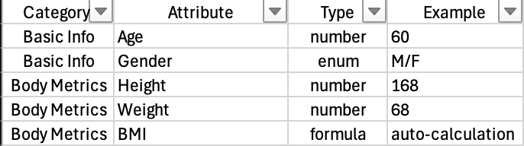

  - Health Goal

  - Dietary Restrictions
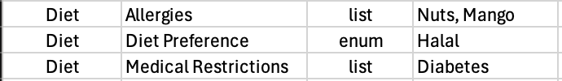

  - Lifestyle and Budget
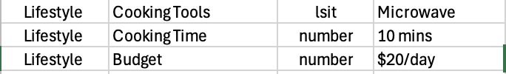
  - Preferences
- Allergy $→$ Restricted Ingredients Mapping
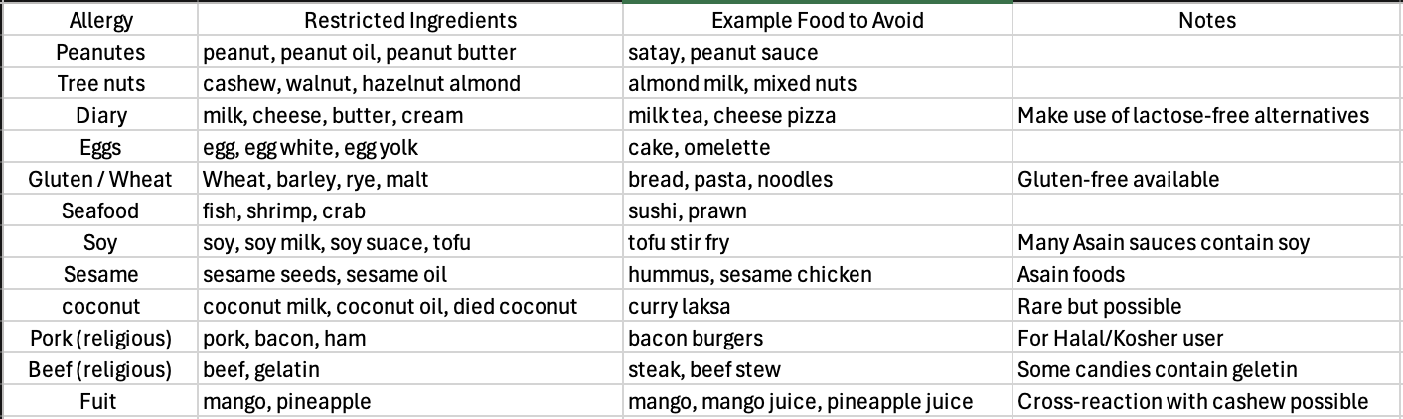

- Personalization Logic
This shows how AI decides what to do.
- Step 1: Collect Attribute
User enters or updates profile.
- Step 2: Use Diet and Allergy Filters
- Take out any meals that contain prohibited substances.
- Use vegetarian, vegan, and halal filters
- Step 3: Calculate Daily Calories
Applying the latter version of the Mifflin-St Jeor Equation.
- Step 4: Calorie Adjustment by Goal
- Fat loss: calories $×$ 0.8
- Gain in muscle: calories $×$ 1.1
- Maintenance: calories $×$ 1.0
- Step 5: Lifestyle-Based Filter
- Only quick meals if the user has ten minutes to cook
- If you only use a microwave, use only microwave-safe foods
- If your money is tight, start with cheap recipes.
- Step 6: Preference Matching
- Boost meals that include your favorite foods
- Take out meals that contain items you don't like.
- Data Structure
Recommended JSON Example
{
“age”: 25,
“gender”: “Female”,
“height”: 168,
“weight”: 68,
“goal”: “fat_loss”,
…….
}
- Conclusion
The user attribute table, allergy-to-ingredient mapping, personalization logic, lifestyle restrictions, and the future growth plan are all included in the AI Personalization Specification Document (v1) that I prepared this week. The meal-plan AI, NutriBot, and database integration efforts will all be guided by this report in the future.

